**WEEK 3**

**Spring Core and Maven  
EXERCISE 1:  
CODE:**

**pom.xml File:**<project xmlns="http://maven.apache.org/POM/4.0.0"

xmlns:xsi="http://www.w3.org/2001/XMLSchema-instance"

xsi:schemaLocation="http://maven.apache.org/POM/4.0.0

http://maven.apache.org/xsd/maven-4.0.0.xsd">

<modelVersion>4.0.0</modelVersion>

<groupId>com.library</groupId>

<artifactId>LibraryManagement</artifactId>

<version>0.0.1-SNAPSHOT</version>

<packaging>jar</packaging>

<name>LibraryManagement</name>

<properties>

<java.version>1.8</java.version>

<spring.version>5.3.33</spring.version>

</properties>

<dependencies>

<!-- Spring Core -->

<dependency>

<groupId>org.springframework</groupId>

<artifactId>spring-core</artifactId>

<version>${spring.version}</version>

</dependency>

<!-- Spring Context -->

<dependency>

<groupId>org.springframework</groupId>

<artifactId>spring-context</artifactId>

<version>${spring.version}</version>

</dependency>

</dependencies>

<build>

<plugins>

<plugin>

<groupId>org.apache.maven.plugins</groupId>

<artifactId>maven-compiler-plugin</artifactId>

<version>3.8.1</version>

<configuration>

<source>1.8</source>

<target>1.8</target>

</configuration>

</plugin>

</plugins>

</build>

</project>

**applicationContext.xml:**<?xml version="1.0" encoding="UTF-8"?>

<beans xmlns="http://www.springframework.org/schema/beans"

xmlns:xsi="http://www.w3.org/2001/XMLSchema-instance"

xsi:schemaLocation="http://www.springframework.org/schema/beans

http://www.springframework.org/schema/beans/spring-beans.xsd">

<!-- Bean for the BookRepository -->

<bean id="bookRepository" class="com.library.repository.BookRepository" />

<!-- Bean for the BookService with dependency injection -->

<bean id="bookService" class="com.library.service.BookService">

<property name="bookRepository" ref="bookRepository" />

</bean>

</beans>

**BookRepository.java:**package com.library.repository;

public class BookRepository {

public void saveBook(String bookName) {

System.***out***.println("Book saved: " + bookName);

}

}

**BookService.java:**package com.library.service;

import com.library.repository.BookRepository;

public class BookService {

private BookRepository bookRepository;

// Setter for dependency injection

public void setBookRepository(BookRepository bookRepository) {

this.bookRepository = bookRepository;

}

public void addBook(String bookName) {

System.***out***.println("Adding book: " + bookName);

bookRepository.saveBook(bookName);

}

}

**LibraryApp.java:**package com.library;

import com.library.service.BookService;

import org.springframework.context.ApplicationContext;

import org.springframework.context.support.ClassPathXmlApplicationContext;

public class LibraryApp {

public static void main(String[] args) {

ApplicationContext context = new ClassPathXmlApplicationContext("applicationContext.xml");

BookService service = (BookService) context.getBean("bookService");

service.addBook("Harry Potter");

}

}

**RESULT:**

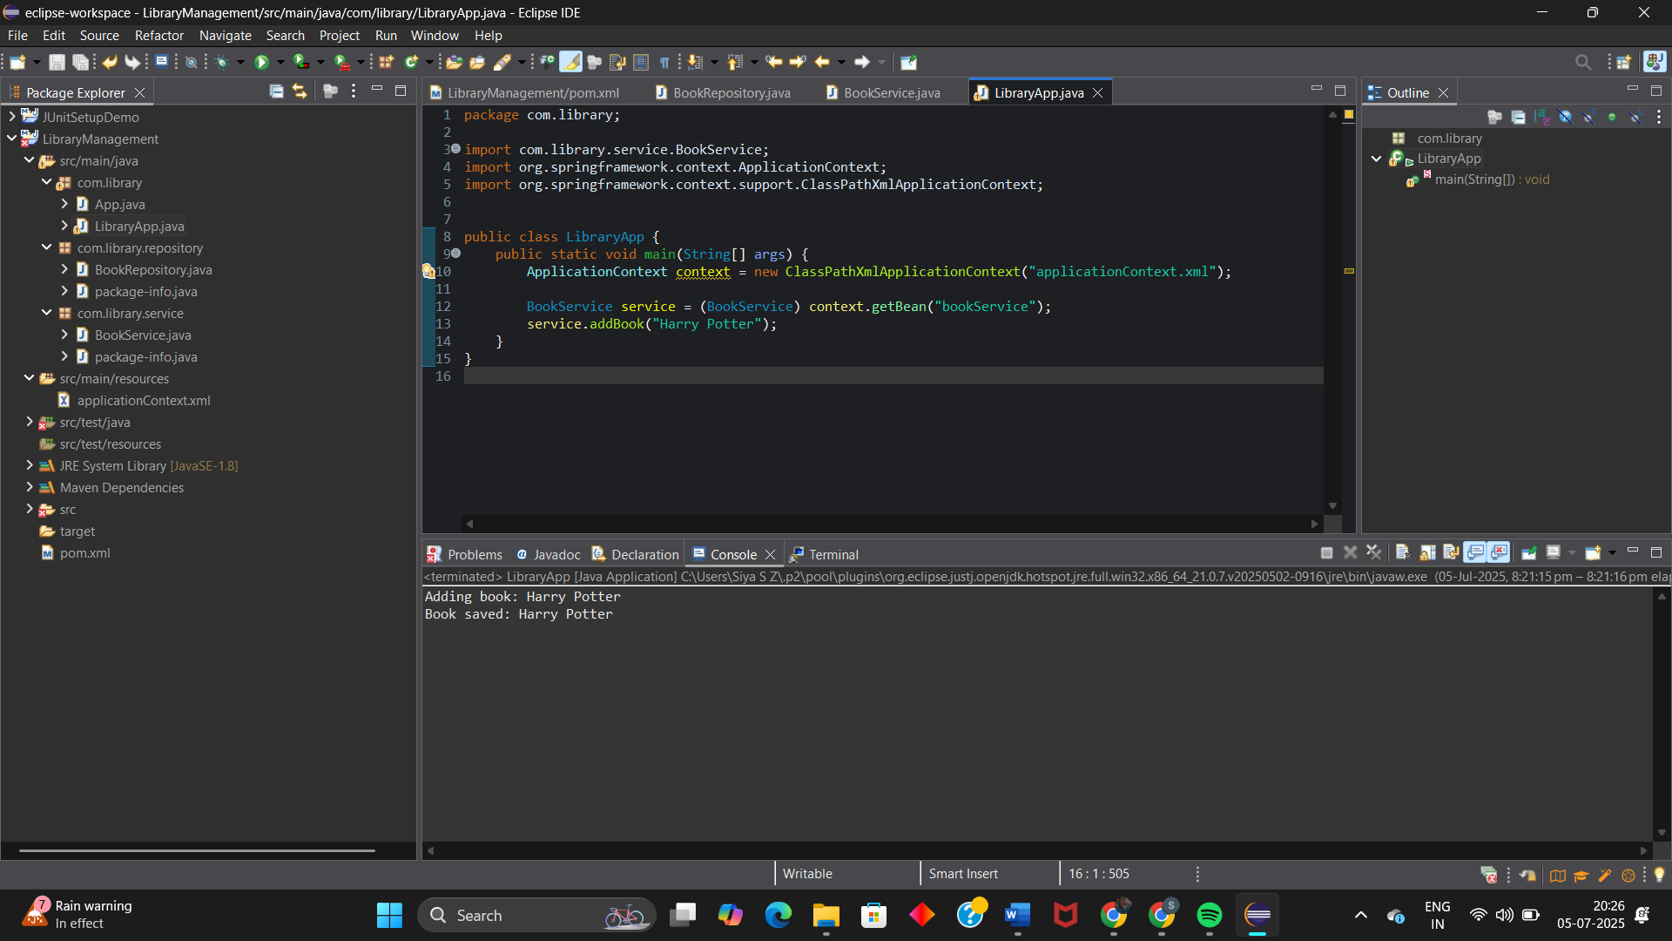

**EXERCISE 2:**

**CODE:**

**pom.xml:**<project xmlns="http://maven.apache.org/POM/4.0.0"

xmlns:xsi="http://www.w3.org/2001/XMLSchema-instance"

xsi:schemaLocation="http://maven.apache.org/POM/4.0.0

http://maven.apache.org/xsd/maven-4.0.0.xsd">

<modelVersion>4.0.0</modelVersion>

<groupId>com.library</groupId>

<artifactId>LibraryManagement</artifactId>

<version>0.0.1-SNAPSHOT</version>

<packaging>jar</packaging>

<name>LibraryManagement</name>

<properties>

<java.version>1.8</java.version>

</properties>

<dependencies>

<!-- Spring Core Dependency -->

<dependency>

<groupId>org.springframework</groupId>

<artifactId>spring-context</artifactId>

<version>5.3.34</version>

</dependency>

<!-- Optional: JUnit for testing -->

<dependency>

<groupId>junit</groupId>

<artifactId>junit</artifactId>

<version>4.13.2</version>

<scope>test</scope>

</dependency>

</dependencies>

<build>

<plugins>

<!-- Compiler Plugin -->

<plugin>

<groupId>org.apache.maven.plugins</groupId>

<artifactId>maven-compiler-plugin</artifactId>

<version>3.8.1</version>

<configuration>

<source>1.8</source>

<target>1.8</target>

</configuration>

</plugin>

</plugins>

</build>

</project>

**applicationContext.xml:**<?xml version="1.0" encoding="UTF-8"?>

<beans xmlns="http://www.springframework.org/schema/beans"

xmlns:xsi="http://www.w3.org/2001/XMLSchema-instance"

xsi:schemaLocation="

http://www.springframework.org/schema/beans

https://www.springframework.org/schema/beans/spring-beans.xsd">

<!-- Define BookRepository bean -->

<bean id="bookRepository" class="com.library.repository.BookRepository" />

<!-- Define BookService bean and inject BookRepository -->

<bean id="bookService" class="com.library.service.BookService">

<property name="bookRepository" ref="bookRepository" />

</bean>

</beans>

**BookRepository.java:**package com.library.repository;

public class BookRepository {

public void save() {

System.***out***.println("BookRepository: Book saved to database.");

}

}

**BookService.java:**package com.library.service;

import com.library.repository.BookRepository;

public class BookService {

private BookRepository bookRepository;

// Setter for Dependency Injection

public void setBookRepository(BookRepository bookRepository) {

this.bookRepository = bookRepository;

}

public void processBook() {

System.***out***.println("BookService: Processing book...");

bookRepository.save();

}

}

**LibraryApp.java:**package com.library;

import com.library.service.BookService;

import org.springframework.context.ApplicationContext;

import org.springframework.context.support.ClassPathXmlApplicationContext;

public class LibraryApp {

public static void main(String[] args) {

// Load Spring context from XML

ApplicationContext context = new ClassPathXmlApplicationContext("applicationContext.xml");

// Retrieve BookService bean from context

BookService bookService = (BookService) context.getBean("bookService");

// Test the injected dependency

bookService.processBook();

}

}

**RESULT:**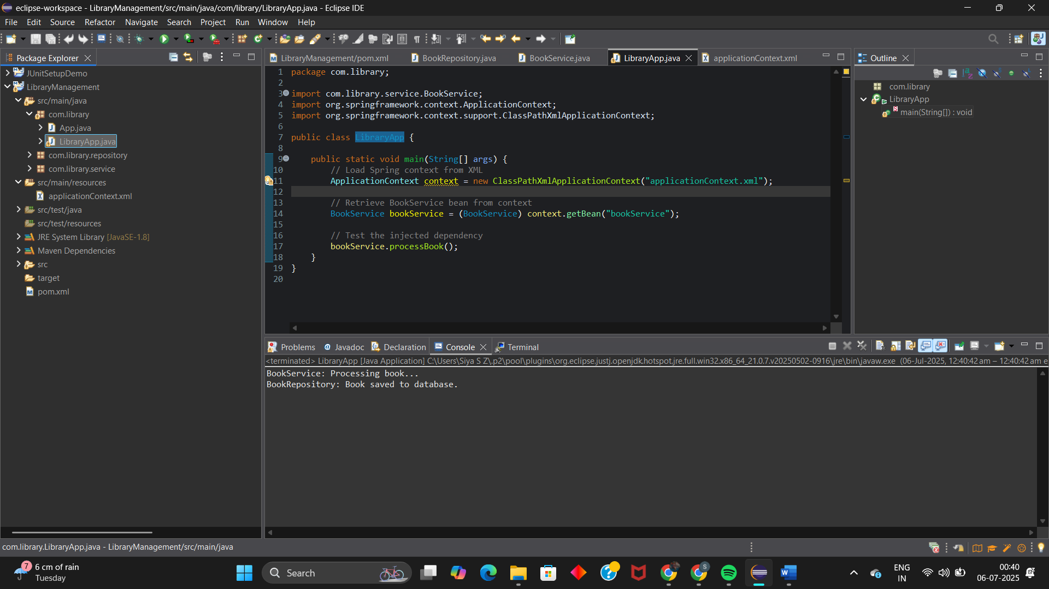

**EXERCISE 3:**

**CODE:  
pom.xml:**<project xmlns="http://maven.apache.org/POM/4.0.0"

xmlns:xsi="http://www.w3.org/2001/XMLSchema-instance"

xsi:schemaLocation="http://maven.apache.org/POM/4.0.0

http://maven.apache.org/xsd/maven-4.0.0.xsd">

<modelVersion>4.0.0</modelVersion>

<groupId>com.library</groupId>

<artifactId>LibraryManagement</artifactId>

<version>1.0-SNAPSHOT</version>

<packaging>jar</packaging>

<name>LibraryManagement</name>

<url>http://www.example.com</url>

<properties>

<maven.compiler.source>1.8</maven.compiler.source>

<maven.compiler.target>1.8</maven.compiler.target>

</properties>

<dependencies>

<!-- Spring Context -->

<dependency>

<groupId>org.springframework</groupId>

<artifactId>spring-context</artifactId>

<version>5.3.30</version>

</dependency>

<!-- Spring AOP -->

<dependency>

<groupId>org.springframework</groupId>

<artifactId>spring-aop</artifactId>

<version>5.3.30</version>

</dependency>

<!-- Spring Web MVC -->

<dependency>

<groupId>org.springframework</groupId>

<artifactId>spring-webmvc</artifactId>

<version>5.3.30</version>

</dependency>

<!-- JUnit (for testing) -->

<dependency>

<groupId>junit</groupId>

<artifactId>junit</artifactId>

<version>4.13.2</version>

<scope>test</scope>

</dependency>

</dependencies>

<build>

<plugins>

<!-- Maven Compiler Plugin -->

<plugin>

<groupId>org.apache.maven.plugins</groupId>

<artifactId>maven-compiler-plugin</artifactId>

<version>3.10.1</version>

<configuration>

<source>1.8</source>

<target>1.8</target>

</configuration>

</plugin>

</plugins>

</build>

</project>

**applicationContext.xml:**<?xml version="1.0" encoding="UTF-8"?>

<beans xmlns="http://www.springframework.org/schema/beans"

xmlns:xsi="http://www.w3.org/2001/XMLSchema-instance"

xsi:schemaLocation="

http://www.springframework.org/schema/beans

https://www.springframework.org/schema/beans/spring-beans.xsd">

<!-- Repository Bean -->

<bean id="bookRepository" class="com.library.repository.BookRepository" />

<!-- Service Bean with Dependency Injection -->

<bean id="bookService" class="com.library.service.BookService">

<property name="bookRepository" ref="bookRepository" />

</bean>

</beans>

**BookRepository.java:**package com.library.repository;

public class BookRepository {

public void saveBook() {

System.***out***.println("BookRepository: Saving the book to the database...");

}

}

**BookService.java:**package com.library.service;

import com.library.repository.BookRepository;

public class BookService {

private BookRepository bookRepository;

// Setter method for Spring to inject BookRepository

public void setBookRepository(BookRepository bookRepository) {

this.bookRepository = bookRepository;

}

public void processBook() {

System.***out***.println("BookService: Starting the book processing...");

bookRepository.saveBook();

System.***out***.println("BookService: Book processing complete.");

}

}

**LibraryApp.java:**package com.library;

import com.library.service.BookService;

import org.springframework.context.ApplicationContext;

import org.springframework.context.support.ClassPathXmlApplicationContext;

public class LibraryApp {

public static void main(String[] args) {

// Load Spring context from XML configuration

ApplicationContext context = new ClassPathXmlApplicationContext("applicationContext.xml");

// Get the BookService bean

BookService bookService = (BookService) context.getBean("bookService");

// Call the business method

bookService.processBook();

}

}

**RESULT:**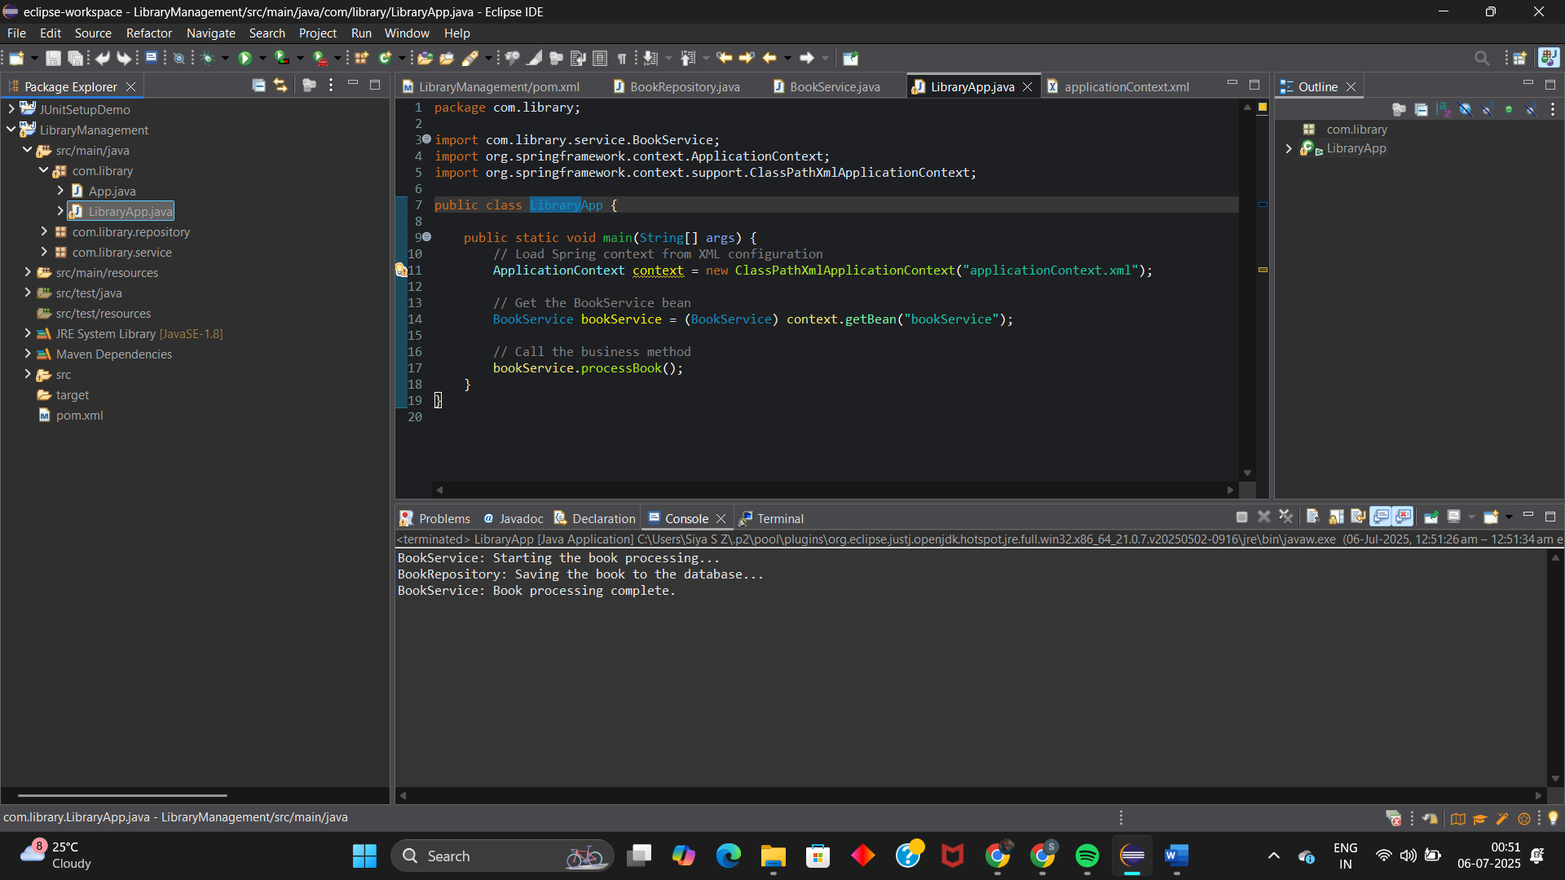

**SPRING JPA:**

**Code:**

**Application.properties:**

# Logging

logging.level.org.springframework=info

logging.level.com.cognizant=debug

logging.level.org.hibernate.SQL=trace

logging.level.org.hibernate.type.descriptor.sql=trace

logging.pattern.console=%d{dd-MM-yy} %d{HH:mm:ss.SSS} %-20.20thread %5p %-25.25logger**{25}** %25M %4L %m%n

# Database Config

spring.datasource.url=jdbc:mysql://127.0.0.1:3306/ormlearn

spring.datasource.username=root

spring.datasource.password= # Leave it blank, do NOT remove the line

spring.datasource.driver-class-name=com.mysql.cj.jdbc.Driver

spring.jpa.hibernate.ddl-auto=update

spring.jpa.show-sql=true

spring.jpa.properties.hibernate.dialect=org.hibernate.dialect.MySQLDialect

**OrmLearnApplication.java:**

package com.cognizant.orm_learn;

import org.springframework.boot.SpringApplication;

import org.springframework.boot.autoconfigure.SpringBootApplication;

import org.slf4j.Logger;

import org.slf4j.LoggerFactory;

*@SpringBootApplication*

public class OrmLearnApplication {

private static final Logger ***LOGGER*** = LoggerFactory.*getLogger*(OrmLearnApplication.class);

public static void main(String[] args) {

SpringApplication.*run*(OrmLearnApplication.class, args);

***LOGGER***.info("🎯 Inside main method - Application started successfully!");

}

}

**Ran into error:**